Advancing User Experience: Utilizing YouTube Transcript for Note-Taking and Text-to-Speech Enhancement in Various Applications

|  | Shriyansh Negi  CSE department  Graphic Era Hill University  Dehradun, Uttrakhand, India  Shriyansh02113@gmail.com |
| --- | --- |

**ABSTRACT**

In today's fast-moving world, where technology is super important, it's crucial to be efficient in how we take in information. This summary talks about two cool ideas to make things better for people: first, automatically getting notes from videos, and second, letting messages in apps be turned into spoken words. These ideas make it easier to take notes, avoid getting overwhelmed with too much info, and make digital interactions better for everyone.

# **Introduction**

Today, technology drives progress and innovation, shaping how we live and work. It's everywhere, making tasks easier and more efficient. One area ripe for improvement is note-taking. Let's explore how technology can revolutionize this aspect of our lives.

Imagine a scenario where students, professionals, or anyone seeking to absorb information from online content could seamlessly extract key points and insights from video lectures or presentations. This is where the concept of automatically generating notes from videos comes into play. By including the transcript feature available on platforms like YouTube, users can effortlessly convert spoken content into written text, which can then be saved into a convenient file format. This not only target the note-taking process but also offers a flexible solution for documentation purposes. Additionally, for individuals who prefer reading over watching videos or those with accessibility needs, having access to transcripts provides an invaluable alternative method of consuming content while ensuring that no crucial information is missed.

Now, let's bump into the potential of enhancing communication experiences through speech-to-text technology within messaging applications. In today's digital age, we are overwhelmed by a never-ending flow of text-based communication across various platforms such as WhatsApp, Instagram, Facebook, and Telegram. People with busy schedules find the act of reading to be time-consuming, and this can lead to information overload

To address this challenge, imagine if users had the option to transform incoming text messages into spoken words with a simple tap of a button. This innovative feature, seamlessly integrated into messaging apps, would enable users to listen to the contents of their messages instead of reading them. By activating the text-to-speech function within the app settings, users can effectively multitask and stay informed while on the go, without the need to dedicate focused attention to reading lengthy messages. This not only enhances user convenience but also promotes accessibility and inclusivity by catering to individuals with visual impairments or those who prefer auditory learning modalities.

In summary, these ideas represent innovative solutions that harness the power of technology to optimize efficiency, streamline workflows, and enhance user experiences across various digital platforms. By embracing these advancements, we can unlock new possibilities for learning, communication, and productivity in the digital age.

# **Literature review**

In numerous prior research studies, the primary focus has been on the conversion of text to speech, yet there has been a notable absence of attention towards incorporating this capability into diverse applications. Additionally, researchers have endeavored to enhance the naturalness of synthesized speech, employing methodologies such as voice modulation and harnessing artificial intelligence (AI) algorithms.

One facet explored in these investigations concerns the enhancement of the authenticity and expressiveness of synthesized speech. Researchers have delved into techniques aimed at imbuing synthesized voices with human-like qualities such as intonation, rhythm, and emotional resonance, with the objective of augmenting the overall auditory experience. Approaches such as prosody modeling and speech synthesis rooted in neural networks have been investigated to achieve speech outputs that emulate natural speech patterns.

Moreover, the advancement of AI has been instrumental in the refinement of text-to-speech systems. Researchers have capitalized on AI algorithms, including sophisticated deep learning methods like convolutional neural networks (CNNs) and recurrent neural networks (RNNs), to decipher intricate speech patterns and generate synthesized voices that closely mimic human speech. Through the training of AI models on extensive datasets of human speech, researchers have strived to capture nuanced characteristics, resulting in synthesized voices that exhibit remarkable resemblance to natural speech.

Furthermore, researchers have delved into the concept of "deepening" synthesized voices, which involves manipulating pitch and timbre to produce a deeper, more authoritative tone. This technique aims to bolster the perceived credibility and authority of synthesized speech, particularly in contexts where a deeper voice conveys a sense of trustworthiness.

In conclusion, these research endeavors underscore the ongoing pursuit of enhancing the fidelity and naturalness of synthesized speech, alongside the integration of text-to-speech technology into diverse applications to enrich user experiences and accessibility. By amalgamating advancements in AI with innovative methodologies for voice synthesis, researchers are laying the groundwork for immersive and engaging interactions with text-based content across an array of platforms and applications.

**Some major gaps in these are: -**

* **Limited Exploration of Application Integration**: While the research acknowledges the need for integrating text-to-speech functionality into diverse applications, it lacks in-depth exploration of the specific challenges and barriers hindering this integration. Future research could delve into practical considerations such as technical compatibility, user interface design, and regulatory constraints that may impede the seamless integration of text-to-speech technology across different platforms and applications.
* **Incomplete Discussion on User Experience**: Although the research briefly mentions enhancing user experiences and accessibility, it overlooks extensive exploration of user preferences, needs, or feedback regarding synthesized speech technologies. Understanding user perceptions, preferences, and usability issues is crucial for designing effective and user-friendly text-to-speech systems. Future research could conduct user studies, surveys, or usability testing to gather insights into user expectations, satisfaction levels, and areas for improvement in synthesized speech applications.
* **Limited Exploration of Ethical and Social Implications**:

The research primarily focuses on technical aspects and advancements in synthesized speech technology, neglecting critical ethical and social considerations associated with the widespread adoption of text-to-speech systems. Future research could explore ethical dilemmas, privacy concerns, and potential societal impacts arising from the use of synthesized speech in various contexts, including media, communication, and education.

* **Lack of Comparative Analysis**: The research fails to provide a comparative analysis of different text-to-speech systems or methodologies. Comparative studies can aid in identifying strengths, weaknesses, and trade-offs associated with different approaches to speech synthesis, assisting researchers and practitioners in making informed decisions about technology adoption and implementation.

# **methodology**

The programs utilize various libraries of python, exception handling concept, basic python, and file handling concept.

Let’s discuss and understand about these.

**PYTHON LIBRARIES: -**

* Python is renowned for its wide collection of libraries that offer pre-written code to perform specific task. In this we don’t have to define or declare, we can just call the different function for different tasks as per the requirements.
* Libraries like: - Google_trans, Google Text-to-speech, playsound, etc.

**EXCEPTION HANDLING CONCEPT: -**

* It a concept for dealing with different types of exceptions that can’t be handle locally.
* These are some statements which are used to handle the exception are: - ‘try’, ‘except’, ‘finally’, etc.
* These are used so that error not be show by the program in case of failure. Instead of showing error in the program, the exception handler transfers the control to where the error can be handled using catch and try block/statements.
* Some types of error are: - ValueError, TypeError, ‘IOError’, etc and these errors are handled appropriately to prevent unexpected termination.

**BASIC PYTHON CONCEPTS: -**

* The program uses all basic concepts of python to achieve its objectives.
* Variables, data type, etc are used to store and manipulation data.
* Control flow statement like if, else, elif, for, and while are used for decision making and iteration.
* Functions are defined and declared to encapsulate the code and to the reusability.

**CONCEPT OF FILE HANDLING: -**

* File handling plays important role for reading and writing of/to files and interaction with external resources.
* File handling operation like: - writing, closing files, reading, opening etc. are performed using some in-built functions and methods.
* It can process different formats as per the program’s requirements.

**WORKING ARCHITECTURE**

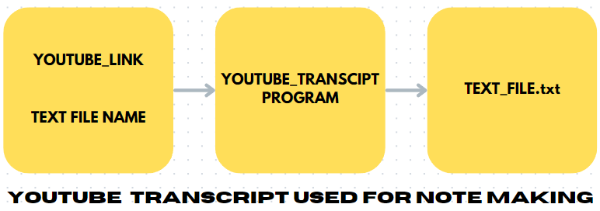

**YOUTUBE TRANSCRIPT FOR NOTE MAKING: -**

* Firstly, importing libraries like youtube_transcipt_api for performing desired operation.
* Then it will ask user to input the site link and pass to the variable.
* Then it will take the name of the file in which user want to put his/her transcript.
* Using the concept of exception handling first check if the entered link is ok then it may proceed further otherwise it will throw an exception.
* Using the API, the transcript is fetched from the site's link entered by the user.
* And then with the help of File handling concept, fetched transcript is written down in the file name which is entered by the user.

**SNIPPET CODE: -**

**Libraries: -**

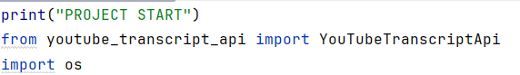

**Code: -**

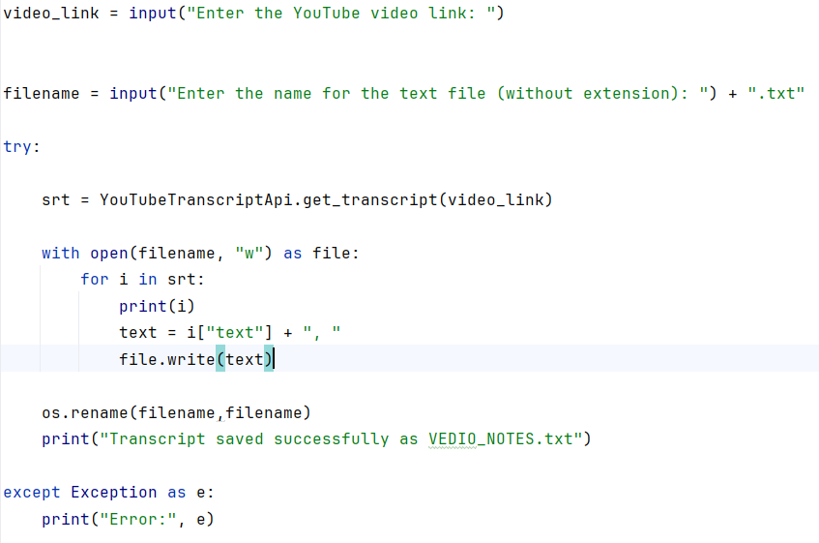

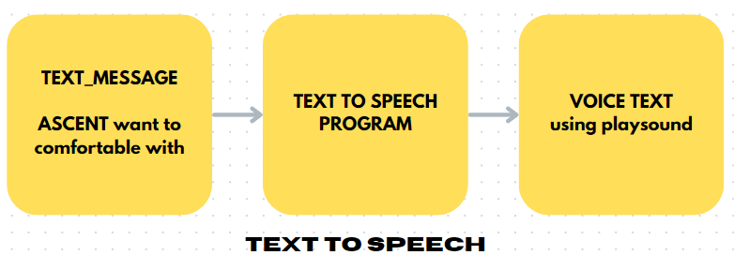

**TEXT TO SPEECH: -**

* Firstly, we import various libraries to perform our desired task. Such as: playsound, google_trans_new, etc. by the user.
* Then, our program prompts the user to input the text they want to listen to in voice format. After entering the text, if the user doesn't want to enter anything else, they simply type "done" at the end.
* The input function terminates and input store to a variable.
* Next, the program displays a menu with different language options for the accent to be listened to.
* After that, the variable containing the text and the chosen accent are passed as arguments to the function named 'text_to_speech'.
* Using the playsound library, the program speaks the text in the selected accent.
* Finally, if the user doesn't want to enter another task, they have the choice to end the program.

**SNIPPET CODE: -**

**LIBRARIES USED: -**

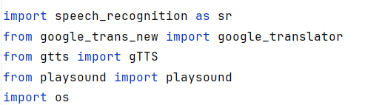

**FUNCTION: -**

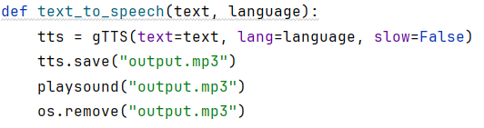

**MAIN PROGRAM: -**

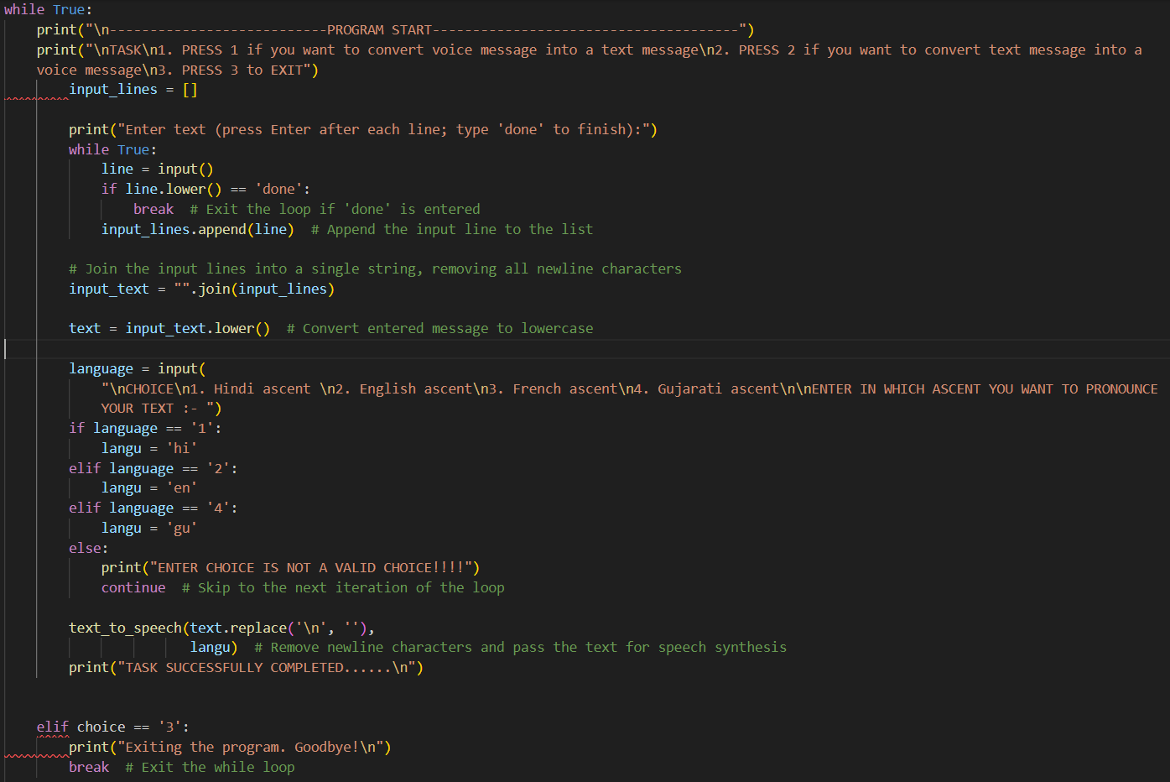

# **Potential for Advancements**

* **Limited ascent**: - While the current implementation may have limited accents, there is potential to expand this feature by including a wider range of accents. This could provide users with a more diverse and natural-sounding experience, akin to human speech rather than machine-generated voices.
* **Converting api**:- Once converted into an API (Application Programming Interface), the functionality of the project can be accessed and utilized by different applications and mobile phones. This opens up opportunities for widespread adoption and integration into various platforms and devices, enhancing accessibility and usability.
* **Collaboration with AI and ML**: - Collaborating the project with Artificial Intelligence (AI) and Machine Learning (ML) technologies could further enhance its capabilities. By leveraging AI and ML algorithms, the project could adapt and improve over time, learning from user interactions and feedback to deliver more accurate and personalized speech synthesis. Additionally, AI-powered features such as voice recognition and natural language processing could be integrated to enable more advanced functionalities and interactions.

# **Conclusion**

* The incorporation of technology into our daily routines continues to propel advancements and innovation, presenting solutions to amplify efficiency and enrich user interactions. This research delves into two pivotal concepts: the automation of **note-taking** from videos and the integration of **speech-to-text** capabilities in messaging platforms. These ideas underscore the transformative potential of technology in reshaping how we consume information and communicate.
* **Automating** the process of note-taking through video transcripts offers users the opportunity to economize time and energy, ensuring the accurate capture of valuable insights. Moreover, the provision of transcripts fosters inclusivity by accommodating diverse learning styles and preferences. Likewise, the fusion of speech-to-text technology into messaging applications addresses the hurdles posed by information overload and time constraints.
* Enabling the conversion of **text messages into spoken words** facilitates **multitasking** and **enhances accessibility**, **empowering** users to stay abreast of information without being tethered to their devices.
* In summary, these innovations signify significant strides in optimizing digital interactions and bolstering productivity within our dynamic contemporary landscape. Embracing and further refining these technological advancements holds promise for facilitating seamless communication, streamlining workflows, and elevating overall user experiences.

##### **References**

1. Klatt, Dennis H. "Review of text‐to‐speech conversion for English." *The Journal of the Acoustical Society of America* 82, no. 3 (1987): 737-793.
2. Dutoit, Thierry. "High-quality text-to-speech synthesis: An overview." *Journal Of Electrical And Electronics Engineering Australia* 17, no. 1 (1997): 25-36.
3. Ren, Yi, Yangjun Ruan, Xu Tan, Tao Qin, Sheng Zhao, Zhou Zhao, and Tie-Yan Liu. "Fastspeech: Fast, robust and controllable text to speech." *Advances in neural information processing systems* 32 (2019).